# duo-admin-api

Duo Admin API

The Duo Admin API provides programmatic access to the administrative functionality of Duo Security's two-factor authentication platform.

The Admin API lets developers integrate with Duo Security's platform at a low level. The API has methods for creating, retrieving, updating, and deleting the core objects in Duo's system: [users](https://duo.com/docs/adminapi#users), [phones](https://duo.com/docs/adminapi#phones), [hardware tokens](https://duo.com/docs/adminapi#tokens), [admins](https://duo.com/docs/adminapi#admins), and [integrations](https://duo.com/docs/adminapi#integrations).

Developers can write applications that programmatically read their Duo account's [authentication logs](https://duo.com/docs/adminapi#authentication-logs), [administrator logs](https://duo.com/docs/adminapi#administrator-logs), and [telephony logs](https://duo.com/docs/adminapi#telephony-logs); read or update account [settings](https://duo.com/docs/adminapi#settings); and retrieve [reports and other information](https://duo.com/docs/adminapi#info).

Review the [API Details](https://duo.com/docs/adminapi#api-details) to see how to construct your first API request.

### Postman Configuration using Pre-built Templates

Setting Up Multiple Environments

Postman environments can be used to allow a user to change the properties/headers of a request on the fly. Since the Duo requests must have the authentication headers regenerated upon each new request, this works REALLY well with environments. Below is an example of how to set this up.

Adding an environment:

1. In Postman, the Environment dropdown lives in the upper right. By default, no environments are configured. To add an environment, click the Eye icon, then click Add: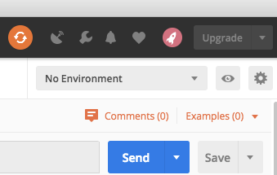

2. Add your specific ikey, skey, apihost as Variables and add your Admin/Auth API integration keys in as the current values.

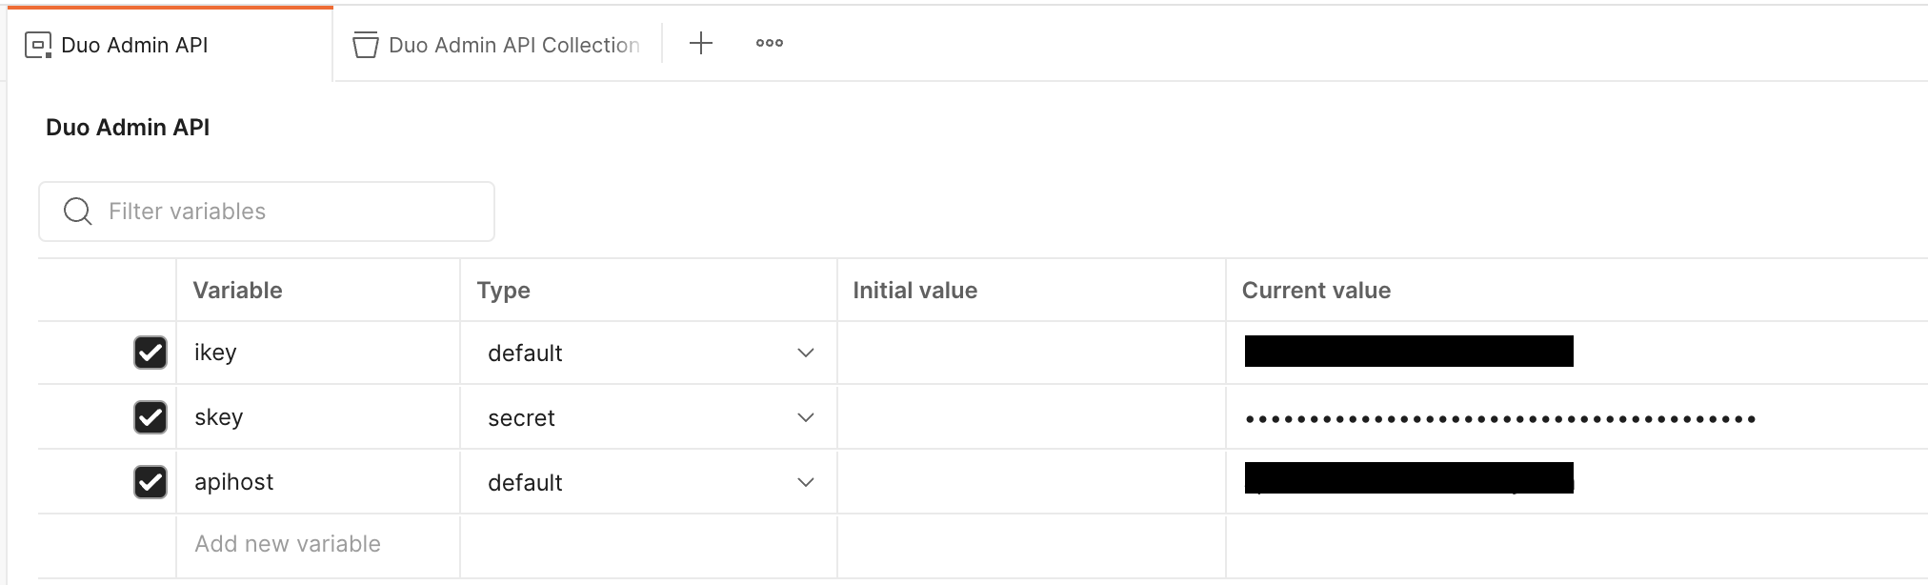

### Import Postman Environment Template

First, the Duo Admin API Postman Environment template needs to be imported into the Postman application.

1. Open the Postman application, if it is not open already.
2. In the left panel, select the **Environments** tile. If there is no **Environments** tile displayed, select the Screenshot 2023-05-09 at 8.38.33 AM.png tile at the bottom of the left panel and then make sure the toggle slider is enabled for the Environments sidebar item.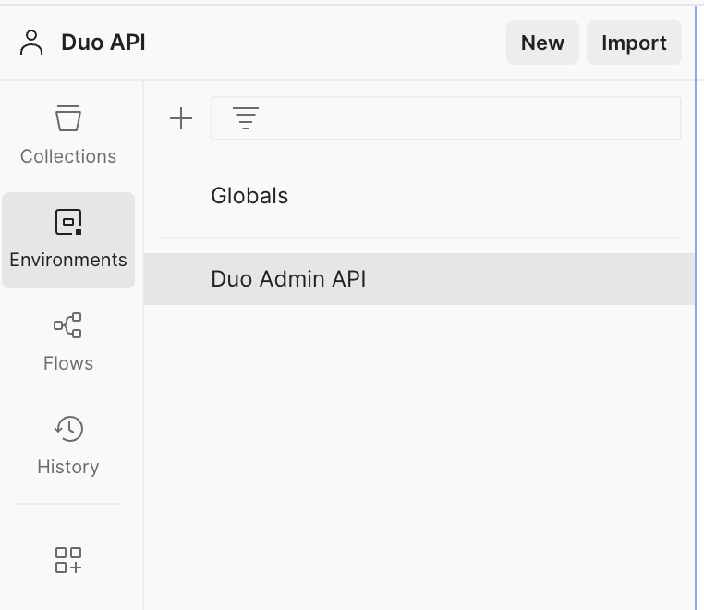

3. Download [this Postman Duo Admin API Environment template file](https://cisco-sbg.atlassian.net/wiki/download/attachments/654904950/Duo%20Auth%20API%20v3.2.0.postman_collection.json?version=1&modificationDate=1740162458092&cacheVersion=1&api=v2).

4. Select the **Import** button in the upper right of the Environments section.

5. Browse to the JSON file downloaded in step #3 above.

6. Select the new Duo Admin API entry and verify that there are variables defined for:

* + ikey
  + skey
  + apihost

### Import Postman Collections Template

Second, the Duo Admin API Postman Collections template needs to be imported into the Postman application.

1. Open the Postman application, if it is not open already.
2. In the left panel, select the **Collections** tile. If there is no **Collections** tile displayed, select the Screenshot 2023-05-09 at 8.38.33 AM.pngtile at the bottom of the left panel and then make sure the toggle slider is enabled for the Collections sidebar item.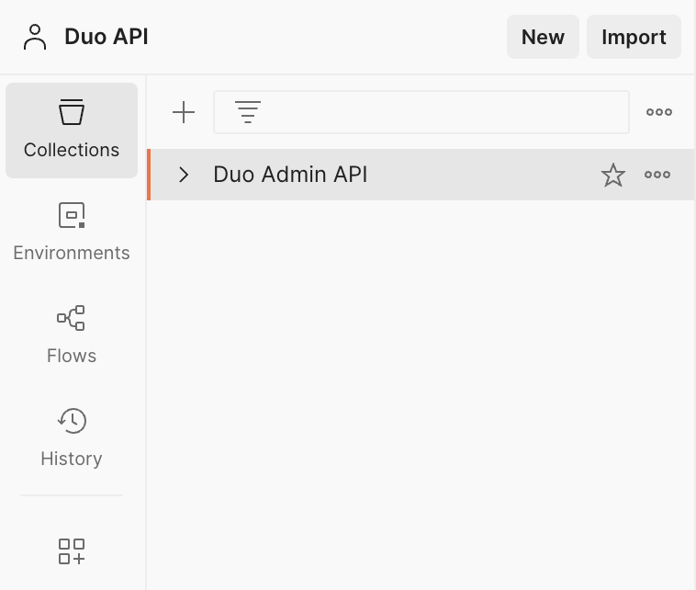

3. Download [this Postman Duo API Collections template file](https://cisco-sbg.atlassian.net/wiki/download/attachments/654904950/Duo%20Auth%20API%20v3.2.0.postman_collection.json?version=1&modificationDate=1740162458092&cacheVersion=1&api=v2).

4. Select the **Import** button in the upper right of the Environments section.

5. Browse to the JSON file downloaded in step #3 above.

6. Select the new Duo Admin API Collection entry and verify the Pre-request Script is populated.

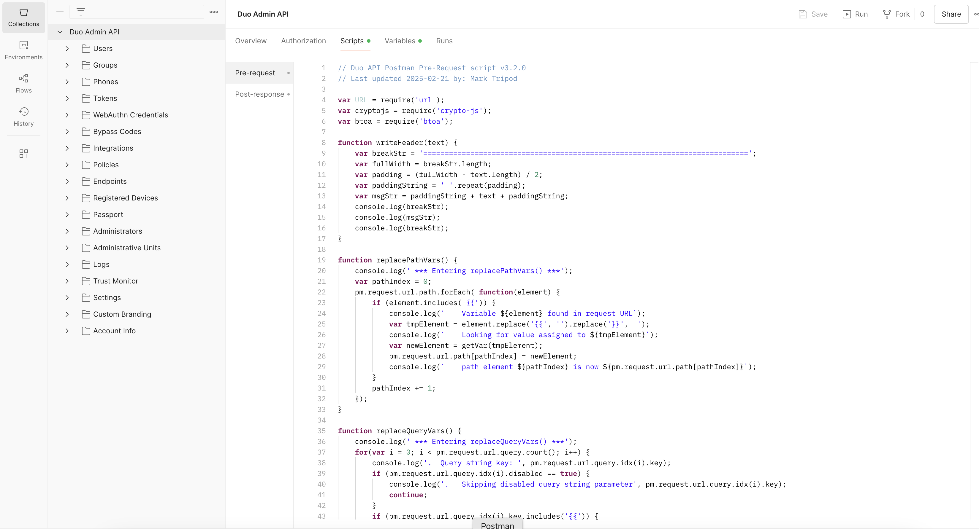

7. Expand the Duo Admin API Collection item to reveal two example requests.

### Using the Templates

Once the templates have been imported, they require the standard three pieces of information from a Duo Admin API application integration.

### Adding the Duo API credentials

Navigate to the **Duo Admin API** environment within Postman and update the Current value rows for each of the **ikey**, **skey**, and **apihost** with information from the Duo Admin API integration from the account will be tested. Click the save button in the upper right if the values should be stored for future use after the Postman application has been closed.